Movie Landing Page Website Design

Name : Vignesh Vannemreddy

Mail Id : vigneshvannemreddy4@gmail.com

Phn No : 7013244414

Roll N0 : 20HU1A0452

College Name : Chebrolu engineering college

**Source Code:**

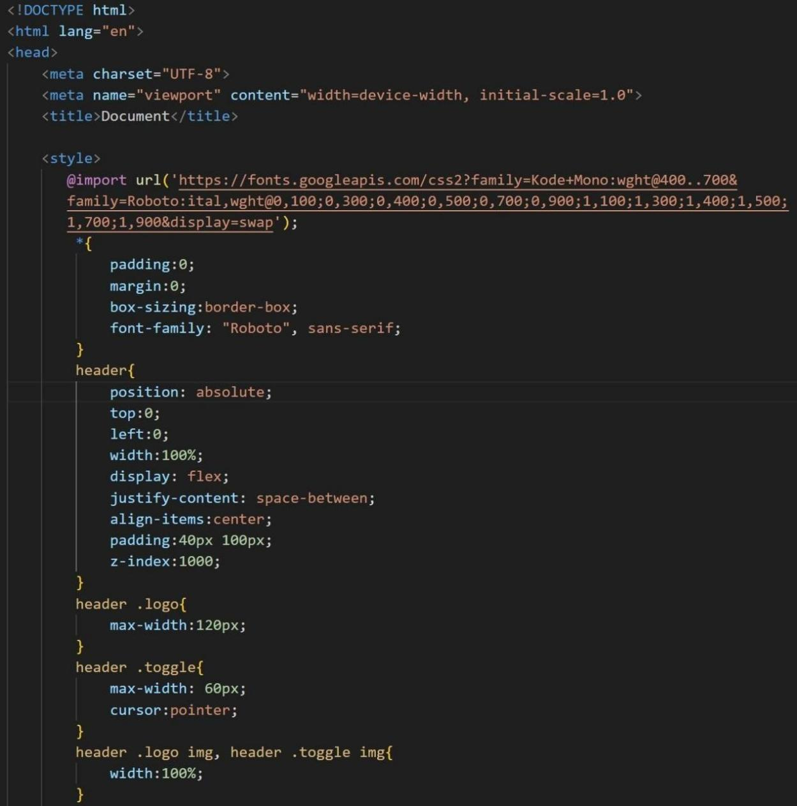

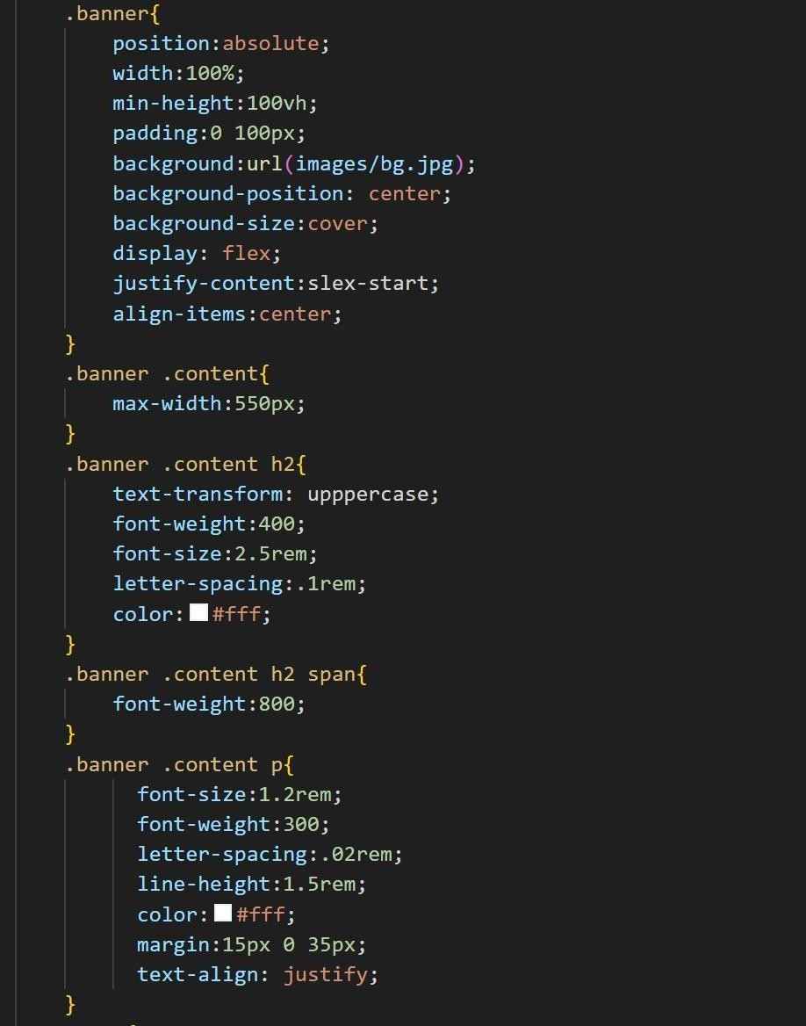

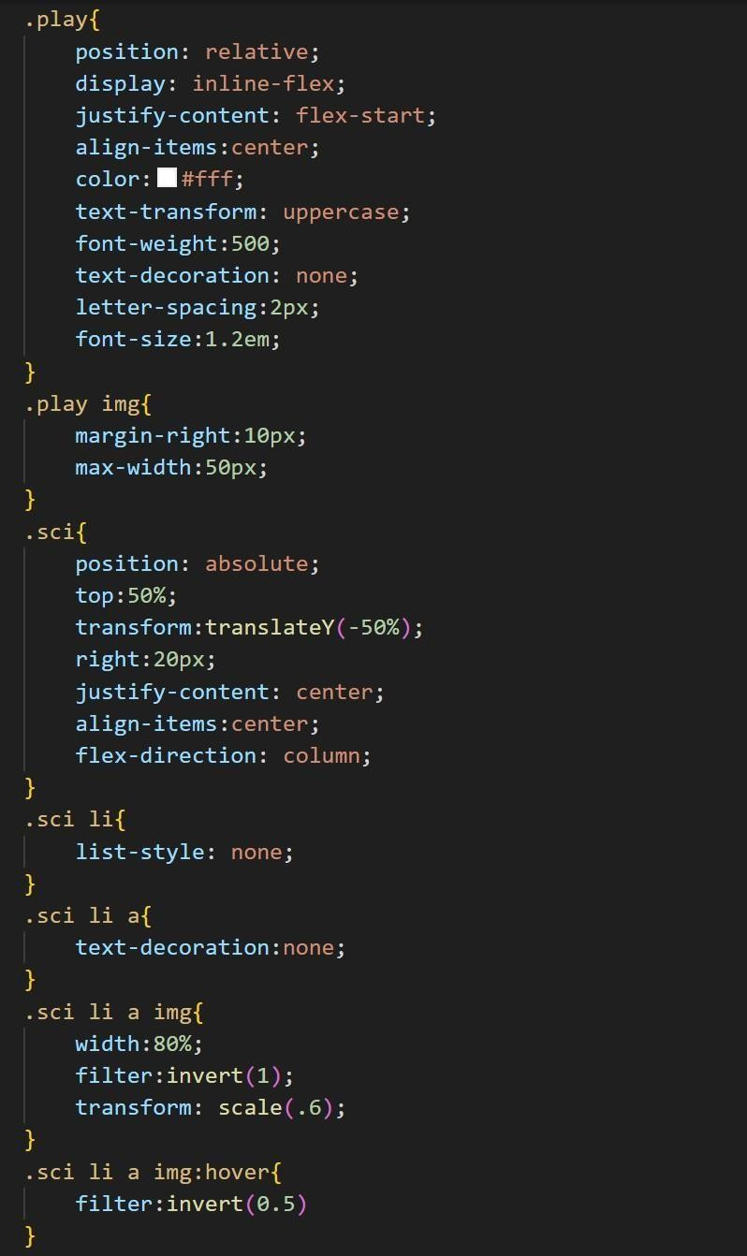

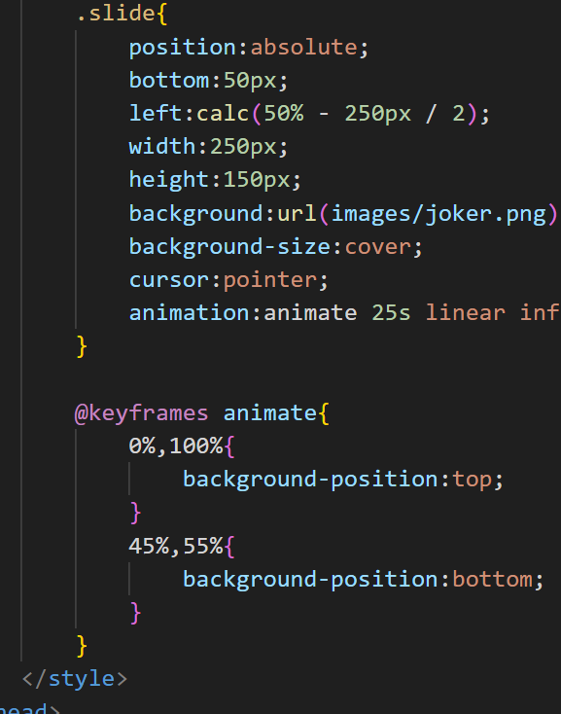

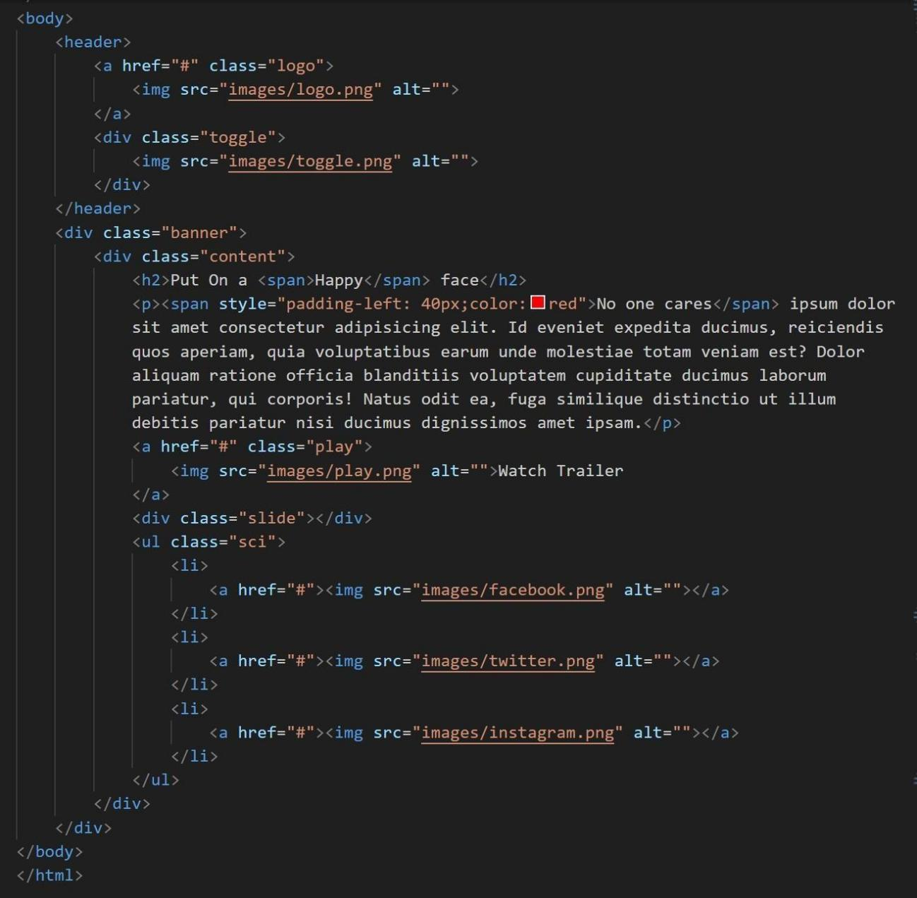



**Output :**